

Boredom Busters

* 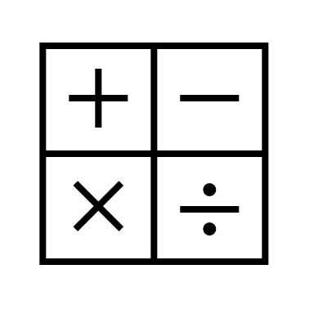Read a book
* Take an AR test
* Practice Math flash cards (with each other)
* 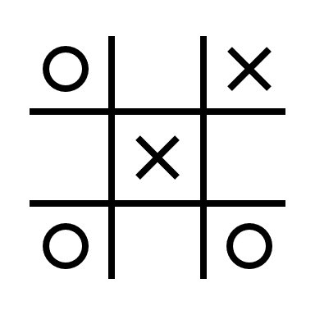Do Math homework
* 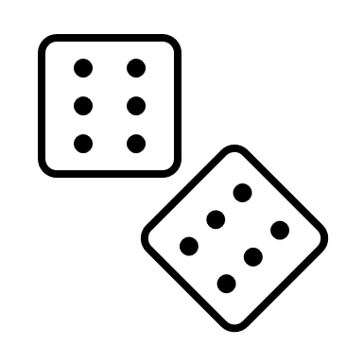Time yourself on multiplication tables
* Flip through the encyclopedia
* Look up definitions of words in the dictionary
* Draw a picture
* Play a game
* Do an activity from the Art Cabinet (crossword, maze, color)
* Do a chore = Earn $1
* Play Wii game (Harry Potter, Mario Cart, Wii Sports)
* Clean room + 1 chore = $5 end of week
* ****Make a video for youtube (plan out the scene, write a script, create a background/set design)
* Make a sock friend
* Practice crochet
* 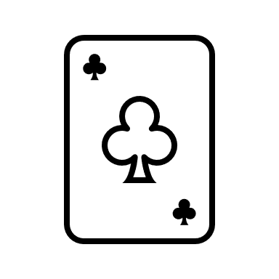Play solitaire
* Try origami
* Make a fortune teller
* 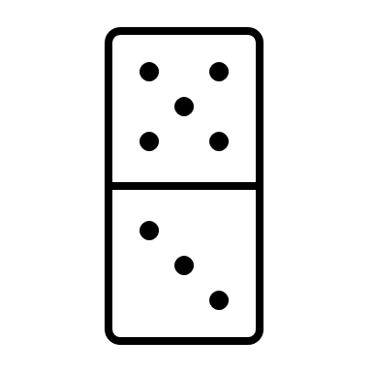Build a fort (and clean it up)
* Make up a new game
* Ride bikes
* A close-up of the moon and the earth

  Description automatically generated with low confidencePlay basketball
* Setup a nerf gun obstacle course or target range